- Experiment Environment Preparation
- Enable Windows Subsystem for Linux (WSL) and Virtual Machine Platform, and set the default WSL version to WSL2.
- Install Docker Desktop and enable WSL integration with Ubuntu.
- Manually download and install Minikube v1.37.0 (Docker driver) in the WSL environment.
- Preload the kicbase image into Docker to avoid network issues during Minikube startup.
- Start Minikube with the Docker driver and verify the Kubernetes cluster creation by running kubectl get nodes (the node status should be Ready).
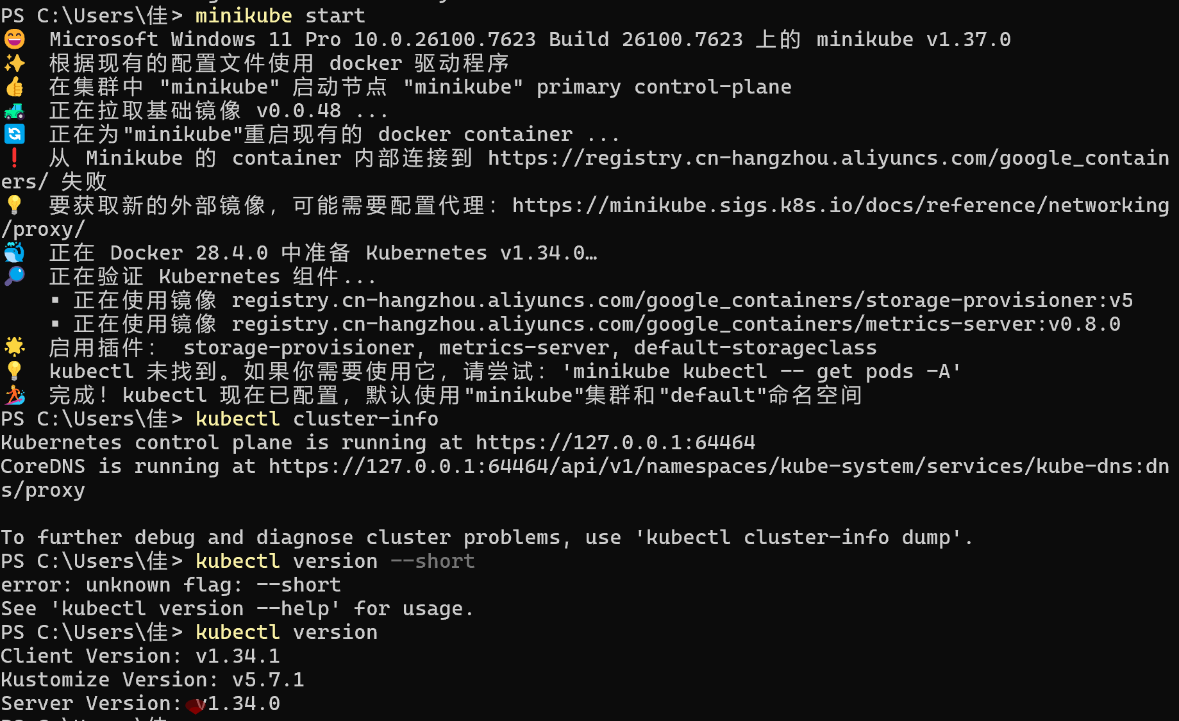
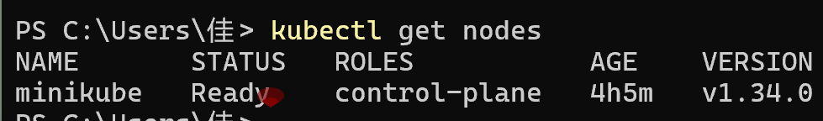
- Download Istio installation package
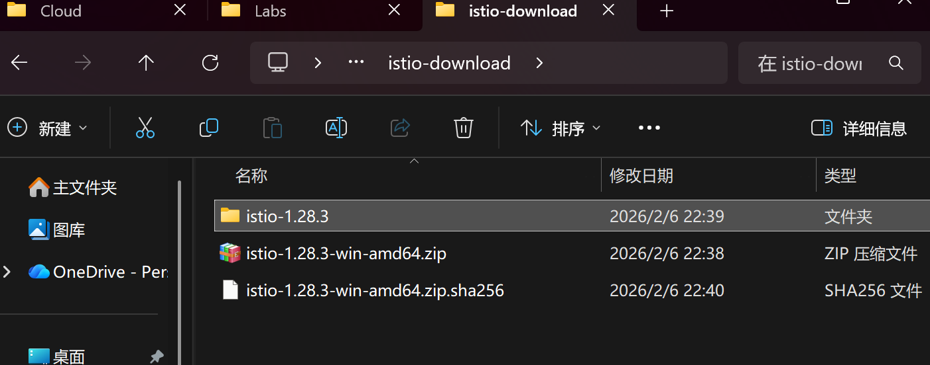
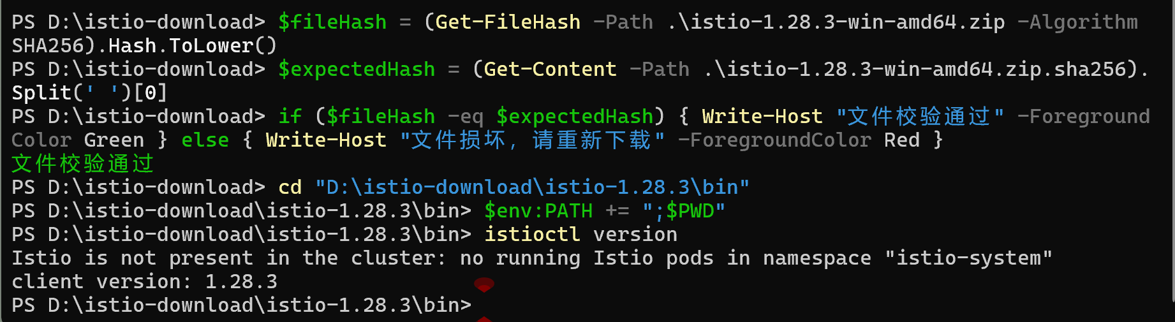
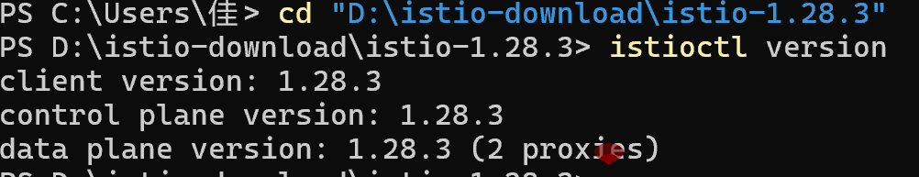
- Install Istio (Demo Configuration File)
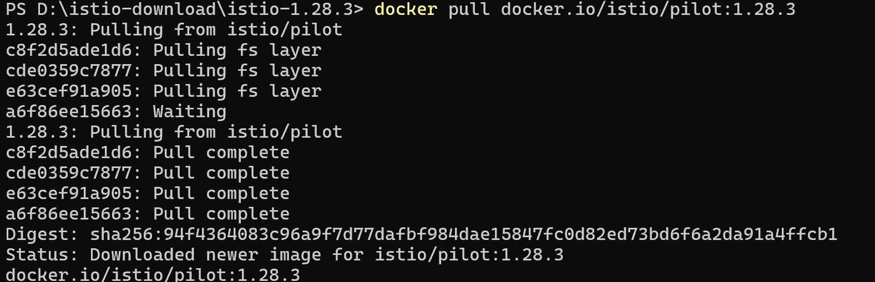
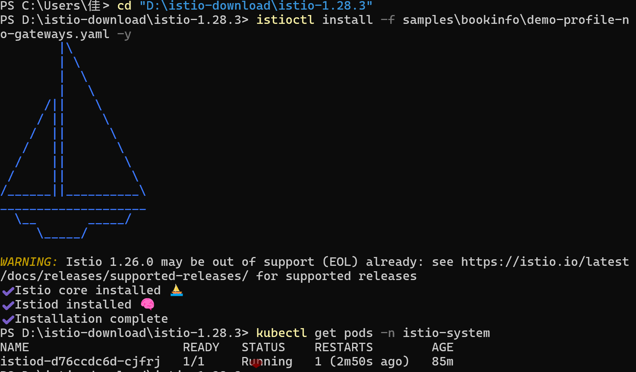
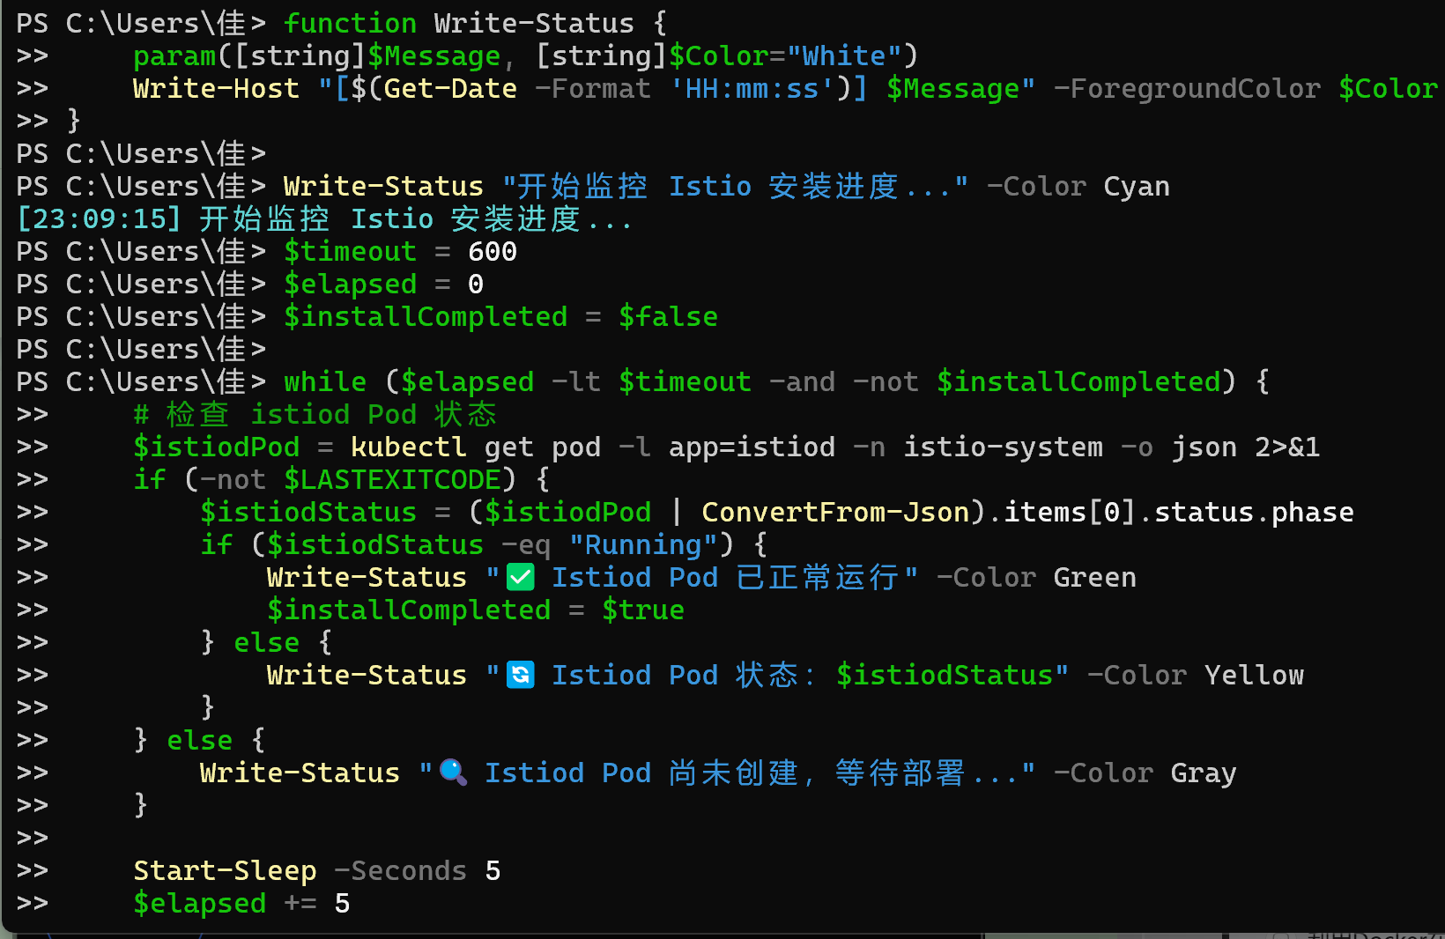
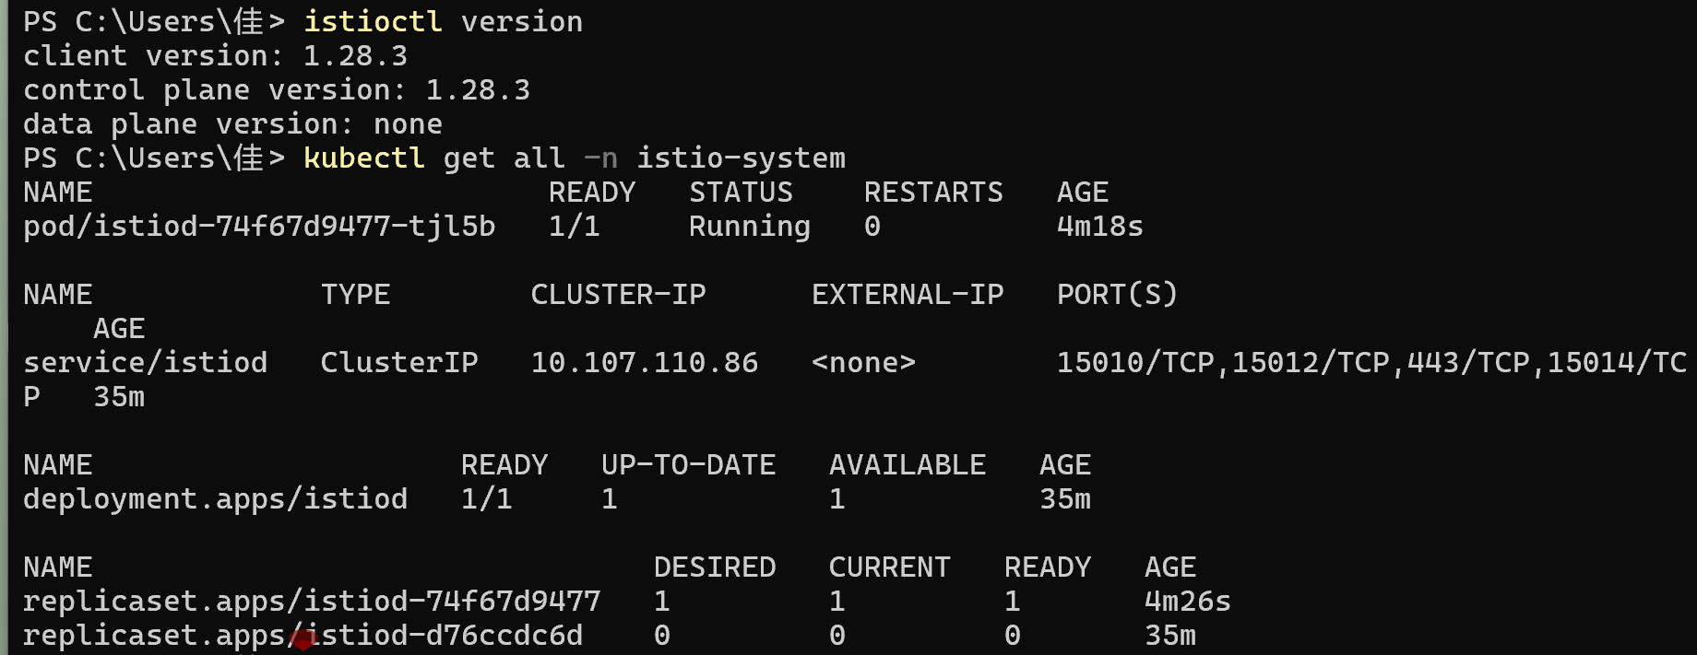
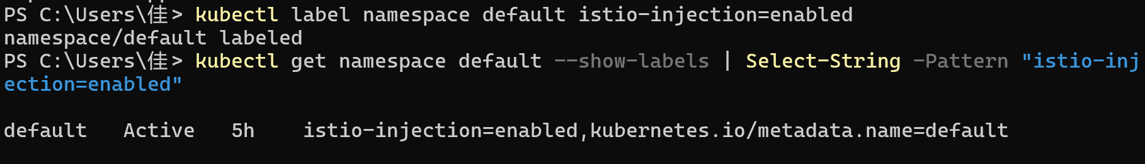
- Install Kubernetes Gateway API CRDs
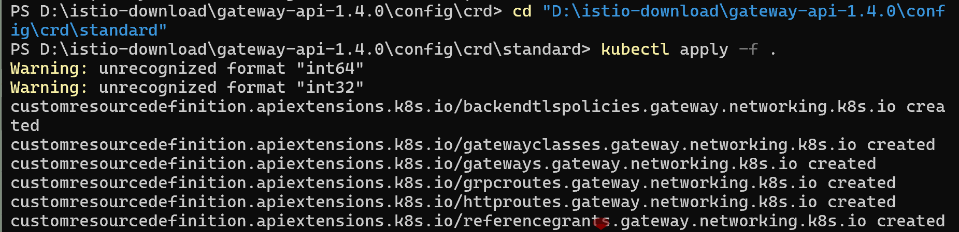
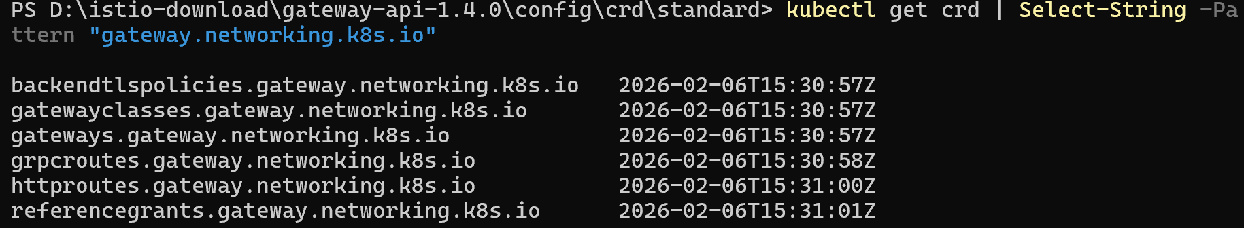
- Deploy the Bookinfo example application
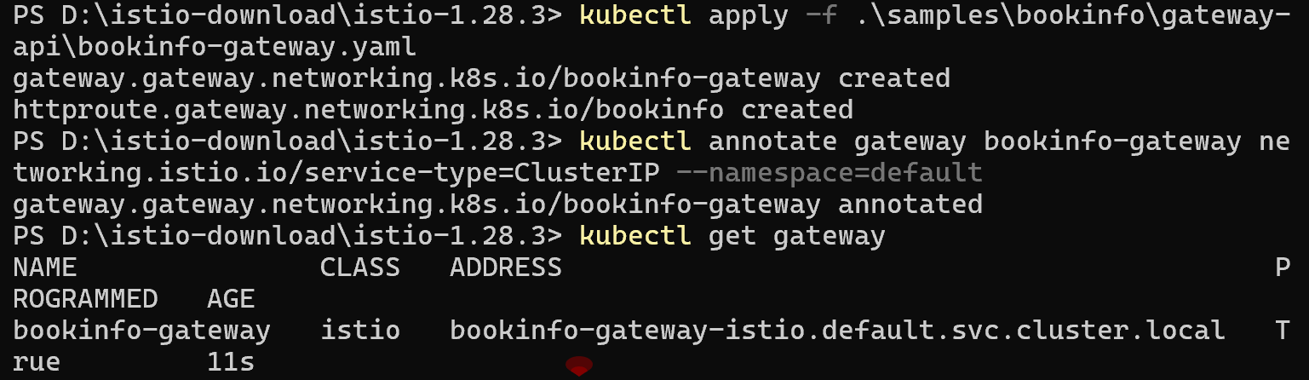
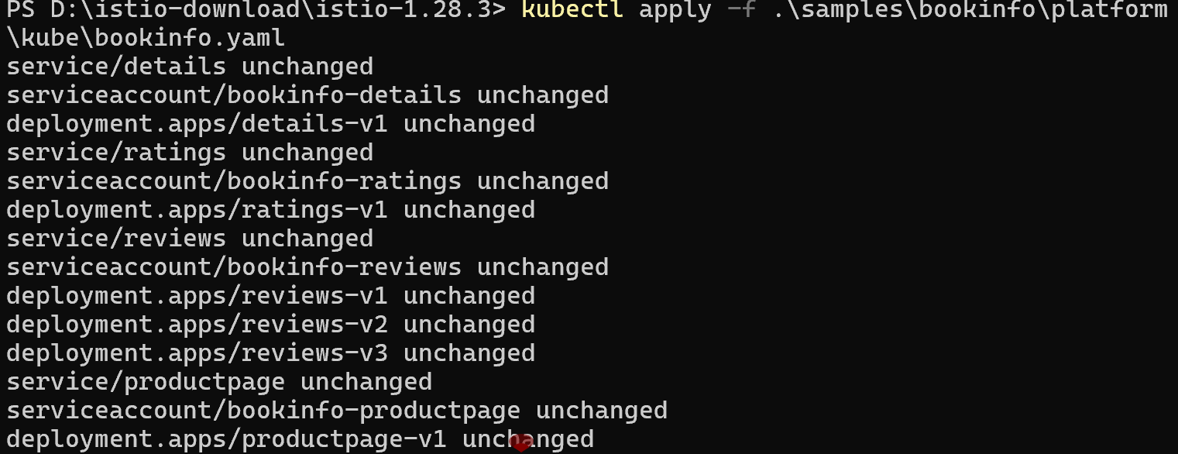
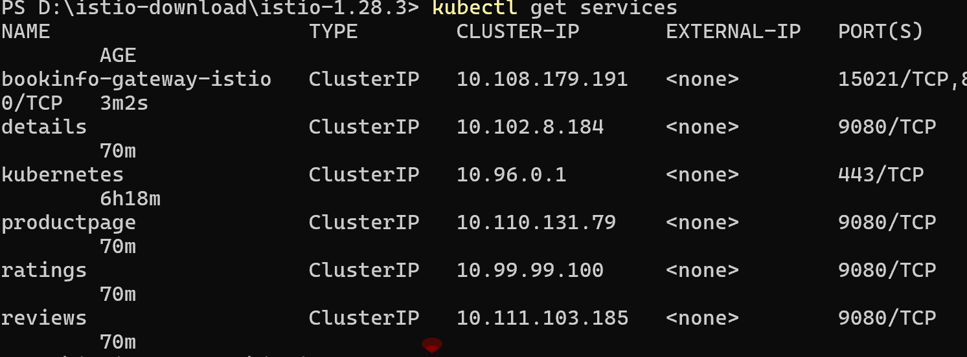
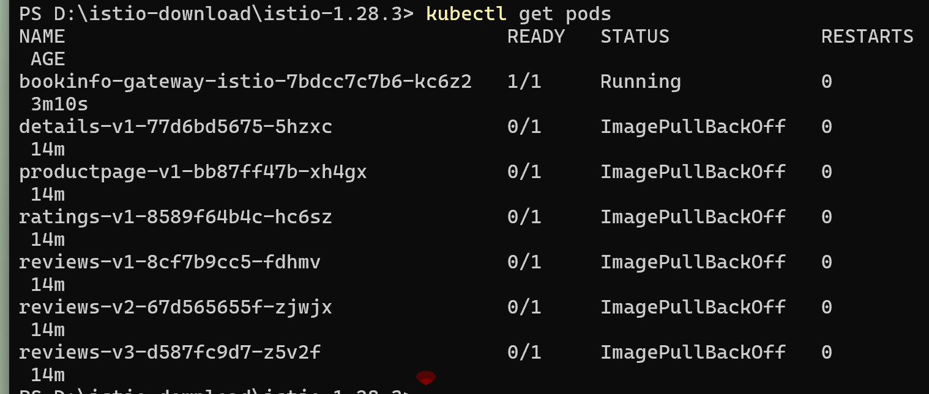

- Configure the gateway and enable external network access for the application
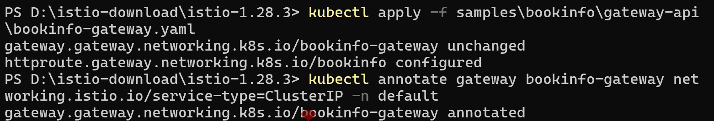
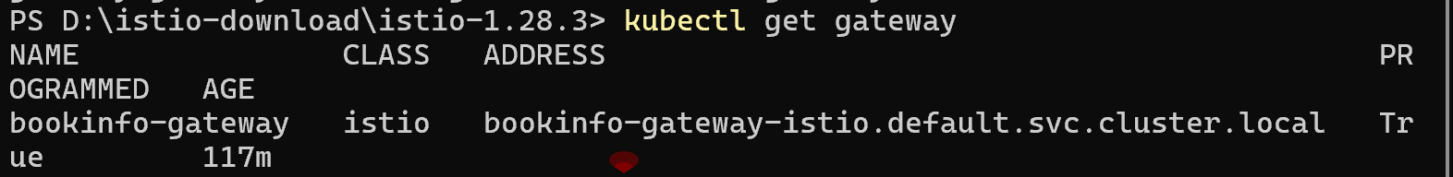
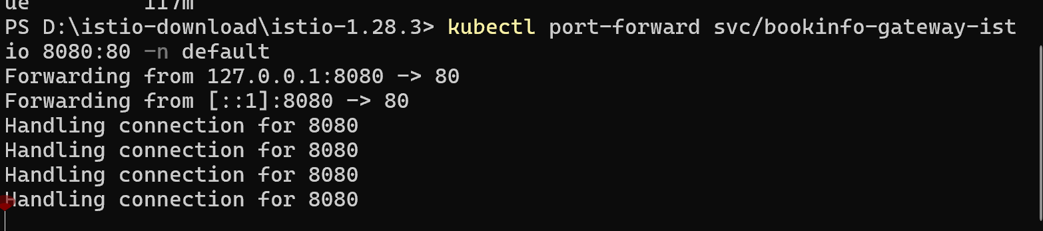
- Deploy and Access the Istio Dashboard (Kiali)
